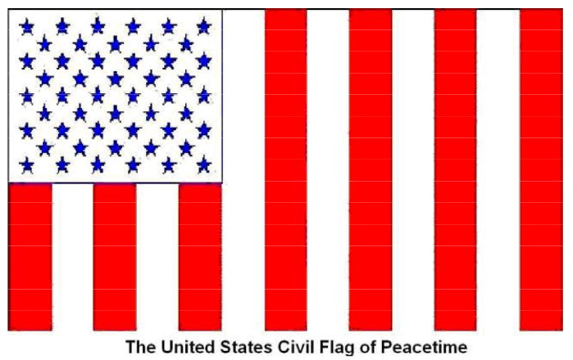
Criminal Information, Notice of Liability and to Correct
Records Made Without Delegation of Authority
<<October 19th of 2025>>
<<Your Name>>
In Care of <<Your street>>
<<Your City>><<Your State>>
To all to whom these presents shall come (Alleged Agents):
1) Whereas: if the alleged incorporated States, per The Constitution of the United States of America and The Constitution of the United States Article I, § 10, Cl. 1, “...make any Thing but gold and silver Coin a Tender in Payment of Debts;” ; and
2) Therefore: are not the alleged incorporated States’ agents, and hence their alleged chartered corporations’ agents, and also hence the alleged incorporated United States of America’s agents, the alleged incorporated United States’ agents, or any of those four (4) hereinafter “Alleged Agents”, operating outside any Sovereign delegation of authority with respect to me, a lawful State Person; and
3) Therefore: what obligation do I, a lawful State Person, have to recognize or be subject to utterances of Alleged Agents operating outside any Sovereign delegation of authority; and
4) Therefore: would not any attempt to address me, a lawful State Person, by any Alleged Agents be a criminal act per Cohens v. Virginia, 6 Wheat. 264, p 404 “...to usurp… [jurisdiction] … would be treason to the Constitution.” and 18 USC 241, 242, 1341, 1962, 2381, 2382, ; and
5) Therefore: do not, Extinguishment Order https://annavonreitz.com/extinguishmentordernotice.pdf , https://annavonreitz.com/proclamation2.pdf and https://annavonreitz.com/noprivatelawissuperior.pdf Public Proclamations, hereby made part of this presentment as if set forth in full, stand unrebutted; and
6) Therefore: any unwarranted actions, inactions, false statements, or presumptions against me a lawful State Person, by Alleged Agents outside Alleged Agents’ Sovereign delegation of authority, thus sans immunity, are deemed mercenary crime(s) and Alleged Agents’ agreement to this Criminal Information, Notice of Liability and to Correct Records Void Delegation of Authority, to the facts, law, notices, terms, and conditions herein, and to a True Bill issued against each said Alleged Agent individually, per day, per each occurrence, at ten million dollars ($10,000,000) lawful money of The United States of America; and
I, in my given name, <<Your Name>, as a <<wo/man>>, a <<Texan (birth state)>> from birth to now, a lawful State Person, do declare under Penalty of Perjury under the Public Law of The United States of America unincorporated this Criminal Information, Notice of Liability and to Correct Records Made Without Delegation of Authority, in the manner of a Quo Warranto, is true, complete, and correct to the best of my knowledge, with no intent to mislead, defraud, deceive, or threaten in any way, as my best effort, to report crime, in "good faith and with clean hands," in common American English, in a lawful manner, not a legal manner, and with my right to accelerate at will, I require 1) through 5) above to be rebutted in kind, posthaste, to substantiate any claim against me, or correct your record(s) within seventy-two (72) hours to show my status as a Sovereign Land Baron, exempt from levy, tax percuse, non-combatant, and to hold me harmless for all past present or future fictitious claims and or those void Sovereign delegation of authority, and a true copy, facsimile or digital scan of this presentment shall be as lawfully binding as an original; and
Notice to Principals is Notice to Agents, Notice to Agents is Notice to Principals; NOTICE TO AGENTS IS NOTICE TO PRINCIPALS; NOTICE TO PRINCIPALS IS NOTICE TO AGENTS
I, standing in my Chisholm v. Georgia, 2 Dall. 419, p 471 (1793) “sovereignty,” accept all gifts without strings and waive all benefits --- just because we have not spoken in a long time doesn't mean we can’t --- and I issue the above, in the form of an affidavit, without prejudice, under a flag foreign to and without the incorporated United States of America or the incorporated United States this <<October 19th 2025>>.

By:_______________________________________________
<<Your Name>
Enclosures:
Politically You Don't Know Who or Where You Are or How You Are Enslaved
#5511 Extinguishment Order
#5527 Proclamation
#5536 No Private Law

Choose Witness or Notarial Block and remove Red words, other block, Witness option:
___________________________________________________________Date: _____________________ Witness
Print Name___________________________________________________________________________
___________________________________________________________Date: _____________________ Witness
Print Name___________________________________________________________________________

Choose Witness or Notarial Block and remove Red words, other block, Notarial option::
<<Your State>> State
<<Your County>>

I__________________________________________________, a Recording Secretary and International Notarial Witness was visited today <<October 19^{h} of 2025>> by the <<wo/man>> known to me to be <<Your Name>>, and said <<wo/man>> did affirm and autograph this Criminal Information, Notice of Liability and to Correct Records Made Without Delegation of Authority in my presence for the purposes stated.

By:__________________________________________

